

SCHOOL OF COMPUTING, ENGINEERING & INTELLIGENT SYSTEMS

COM326 OBJECT ORIENTED PROGRAMMING
TEAM ASSIGNMENT
COURSEWORK SUBMISSION COVER SHEET

This sheet must be completed in full by all team members and attached to the front of the assessment before submission.

Submitted work is subject to the following assessment policies:

1 Coursework must be submitted by dates as specified by the Course/Subject Committee.

2 Students may seek prior consent from the Course/Subject Director to submit coursework after the official deadline; such requests must be accompanied by a satisfactory explanation, and in the case of illness by a medical certificate.

3 Coursework submitted without consent after the deadline will not normally be accepted and will therefore receive a mark of zero.

I declare that this is all my own work. Any material I have referred to has been accurately referenced and any contribution of Artificial Intelligence technology has been fully acknowledged. I have read the University’s policy on academic misconduct and understand the different forms of academic misconduct. If it is shown that material has been falsified, plagiarised, or I have otherwise attempted to obtain an unfair advantage for myself or others, I understand that I may face sanctions in accordance with the policies and procedures of the University. A mark of zero may be awarded and the reason for that mark will be recorded on my file.

Student Name | Student Number | Student’s Signature | Date
Cillian Okane | B00985074 | Cillian Okane | 17/11/2025
William Donald | B00983098 | William Donald | 17/11/2025
Aaron Okane | B00935029 | Aaron Okane | 17/11/2025
Aajon tench | B00849099 | Aajon tench | 17/11/2025
Ryan Knipe | B00865560 | Ryan knipe | 17/11/2025

Task 1. Class diagram
Objective: Your team will create a single class diagram that accurately represents the structure and relationships of the classes required for the Online shop application.

Class diagram important features
Your team must describe in detail all of the important features of your class diagram in this section. Important discussions include the classes and their properties, visibility, and methods. You must describe the logic behind your relationship decisions between each class as well as inheritance, association, aggregation, composition, multiplicity (if any).
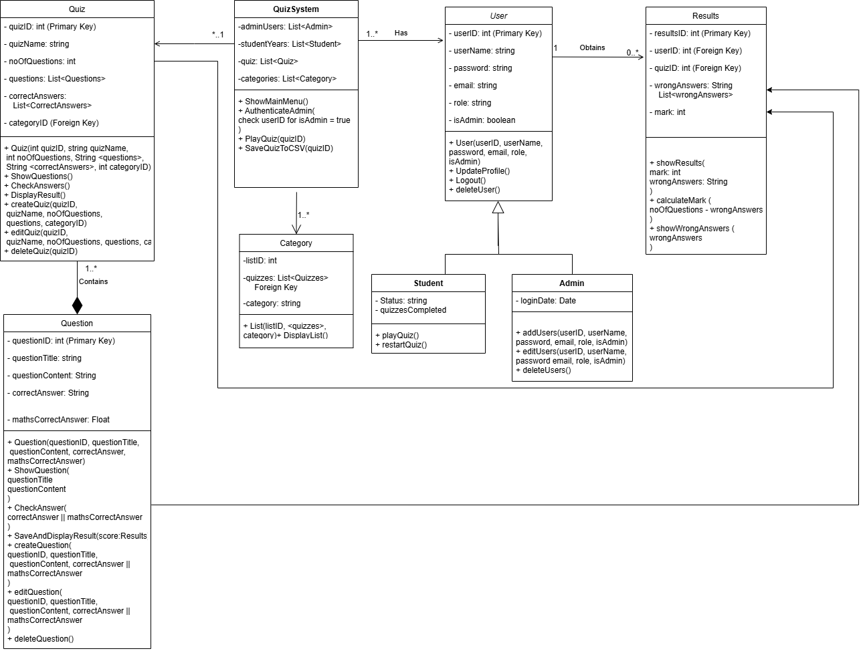

Classes and their properties
The UML diagram above gives a clear overview of how our system works.
The quiz system class, which basically runs the application it keeps private lists which are admins (list), students (list), quizzes (list) and categories (list).
The quiz class stores key details like the quiz ID (int, primary key), quiz name (string), number of questions (int) and its list of questions, correct answers, category id (Foreign key).
The User class stores information User id (int, primary key), user name (string), password (string), email (string), role (string), is admin (Boolean).
The results class stores results id (int, primary key), user id (int, foreign key), quiz id (int, foreign key) it also includes wrong answers (string) and mark (int).
The question class stores question id (int, primary key), question title (string), question content (string), correct answer (string) and maths correct answer (float).
The category class stores list id (int), quizzes list (foreign key) and category (string).
The student class includes status (string) and quizzes (string).
While the admin class includes login Date (int)

Visibility
Quiz class
- + quiz, show questions, check answers, display result, create quiz, edit quiz, delete quiz
- - Quiz id, quiz name, number of questions, correct answers and category id
Quiz system
- + show main menu, authenticate admin, paly quiz and save quiz to csv
- - admin users, student years, quiz list and categories.
User
- + user, updated profile, logout, deleted user
- - user id, user name, password, email, role, is admin.

Results
- + show results, calculate mark, show wrong answers
- - results ID, user ID, quiz ID, Wrong answers, mark
Question
- + Question, show question, check answer, save and display result, create question, edit question, delete question
- - Question ID, Question Title, Question Content and Maths correct answer
Category
- + List ID
- - Quizzes and category
Student
- + Play quiz and restart quiz
- - Status and quizzes
Admin
- + Add users, edit users and delete users
- - Login date

Methods:
QuizSystem
+ ShowMainMenu()
Displays the Main menu of the program wherever the user is in the program.
+AuthenticateAdmin(userID)
Checks to ensure user is authorised to perform admin tasks
+ PlayQuiz(quizID)
This allows any user to play a quiz but unlike the playQuiz() student method which will be shown later. Does not necessarily mean results will be stored.
+ SaveQuizToCSV(quizID)
This is to save a quiz to a CSV file to allow for exporting
User
+ UpdateProfile()
This allows the user to change personal details of their own profile (should we decide to add this functionality later on)
+ Logout()
Allows user to log out.
+ deleteUser()
This allows a user to delete their own profile.
Student
+ playQuiz()
This allows a student user to play a quiz and unlike the general PlayQuiz method. Does indeed save the results.
+ restartQuiz()
This allows a student user to wipe their current score for a quiz and reattempt it as if they were answering it for the first time.
Admin
+ addUsers(userID, username, password, email, role, isAdmin)
This allows an Admin user to create new users. Both admins and students.
+ editUsers(userID, username, password, email, role, isAdmin)
This allows an Admin user to edit users. Both admins and students.
+ deleteUsers()
This allows an Admin user to delete existing users. Both admins and students.
Results
+ showResults(mark, wrongAnswers)
This allows a user to display their results.
+ calculateMark(noOfQuestions, wrongAnswers)
This calculates the mark the user obtained in a quiz by taking the noOfQuestions in a quiz and subtracting the saved wrongAnswers for a quiz.
+ showWrongAnswers(wrongAnswers)
This displays the answers a student answered incorrectly in a quiz.
Quiz
+ ShowQuestions()
This displays all questions related to a quiz.
+ CheckAnswers()
This checks that the user has entered valid inputs in the quiz.
+ DisplayResult()
This pulls the result of a quiz immediately after it has been completed so if the user re-enters the quiz it displays their result at the top.
+ createQuiz(quizID,
quizName, noOfQuestions,
questions, categoryID)
This allows admin users to create new quizzes by combining questions.
+ editQuiz(quizID,
quizName, noOfQuestions, questions, categoryID)
This allows admin users to edit existing quizzes.
+ deleteQuiz(quizID)
This allows admin users to delete existing quizzes.
Question
+ ShowQuestion(
questionTitle
questionContent
)
This displays an individual question in a quiz.
+ CheckAnswer(
correctAnswer || mathsCorrectAnswer
)
This individually checks each answer in a quiz.
+ SaveAndDisplayResult(score:Results)
This calculates and saves the users marks to the results table and then displays it.
+ createQuestion(
questionID, questionTitle,
questionContent, correctAnswer ||
mathsCorrectAnswer
)
This allows an admin user to create a new question.
+ editQuestion(
questionID, questionTitle,
questionContent, correctAnswer ||
mathsCorrectAnswer
)
This allows an admin user to edit an existing question.
+ deleteQuestion()
This allows an admin user to delete an existing question.
Category
+ DisplayList()
This displays all of the quizzes in a given category.

